Abstract

A simple software to manage a clinic

**Clinic Management System**



Submitted By: Marawan Esam - Yousef Adel - Ahmed Yasser - Mohamed Ayman - Mohamed Ehab - Yousef Mamdouh - Mohamed Emad

Table of Contents

**Introduction:** 2

**Entities:** 2

**Attributes:** 2

-Patients: 2

-Medical Records: 3

-Doctors: 3

-Rooms: 3

-Branches: 3

-Staff: 4

-Bills: 4

**Notes:** 4

**ER – Diagram:** 5

**Relational Model Map:** 6

Table of Figures

Figure 1 ER Diagram 4

Figure 2 Mapping 5

Table of Abbreviations

ERD: Entity Relationship Diagram

Email: Electronic Mail

ID: Identification

# **Introduction:**

**Nowadays, many systems have been developed to make life easier. The Clinic management system will include a database that will record all the important data for the doctors, patients, medical records and more. Usually, digital systems are used to record the patient’s information and other information that is related to a clinic. There are many systems for a clinic management system, but they do not meet the local user requirements that are still new in the electronic system.**

# **Entities:**

1. Patients
2. Medical records
3. Doctors
4. Rooms
5. Clinic
6. Staff
7. Bills

# **Attributes:**

## -Patients:

1. P-ID
2. P-Name
3. P-Address
4. P-BirthDate
5. P-Age
6. P-PhoneNum
7. P-Diagnosis
8. P-Appointment
9. P-Registration
10. P-Payment
11. P-Email

## -Medical Records:

1. M-ID
2. M-MedicalProblem
3. M-MedicineRequired

## -Doctors:

1. D-ID
2. D-Name
3. D-Salary
4. D-Qualifications
5. D-Schedule
6. D-Specialty
7. D-PhoneNum
8. D-Email

## -Rooms:

1. R-ID
2. R-Type

## -Branches:

1. B-BranchNum
2. B-PhoneNum
3. B-Specifications
4. B-WorkTimes
5. B-Location
6. B-Expenses
7. B-Profit
8. B-Income

## -Staff:

1. S-ID
2. S-Name
3. S-Type
4. S-Email
5. S-PhoneNum

## -Bills:

1- Bi-ID

1. Bi-Price
2. Bi-Status
3. Bi-Type
4. Bi-Description
5. Bi-Date

# **Notes:**

1. Record relation -> recordDate attribute
2. PayOff relation -> payDate attribute

# **ER – Diagram:**

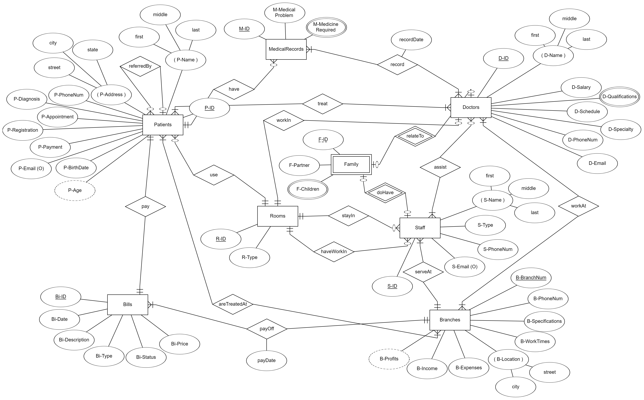

Figure ER Diagram

# **Relational Model Map:**

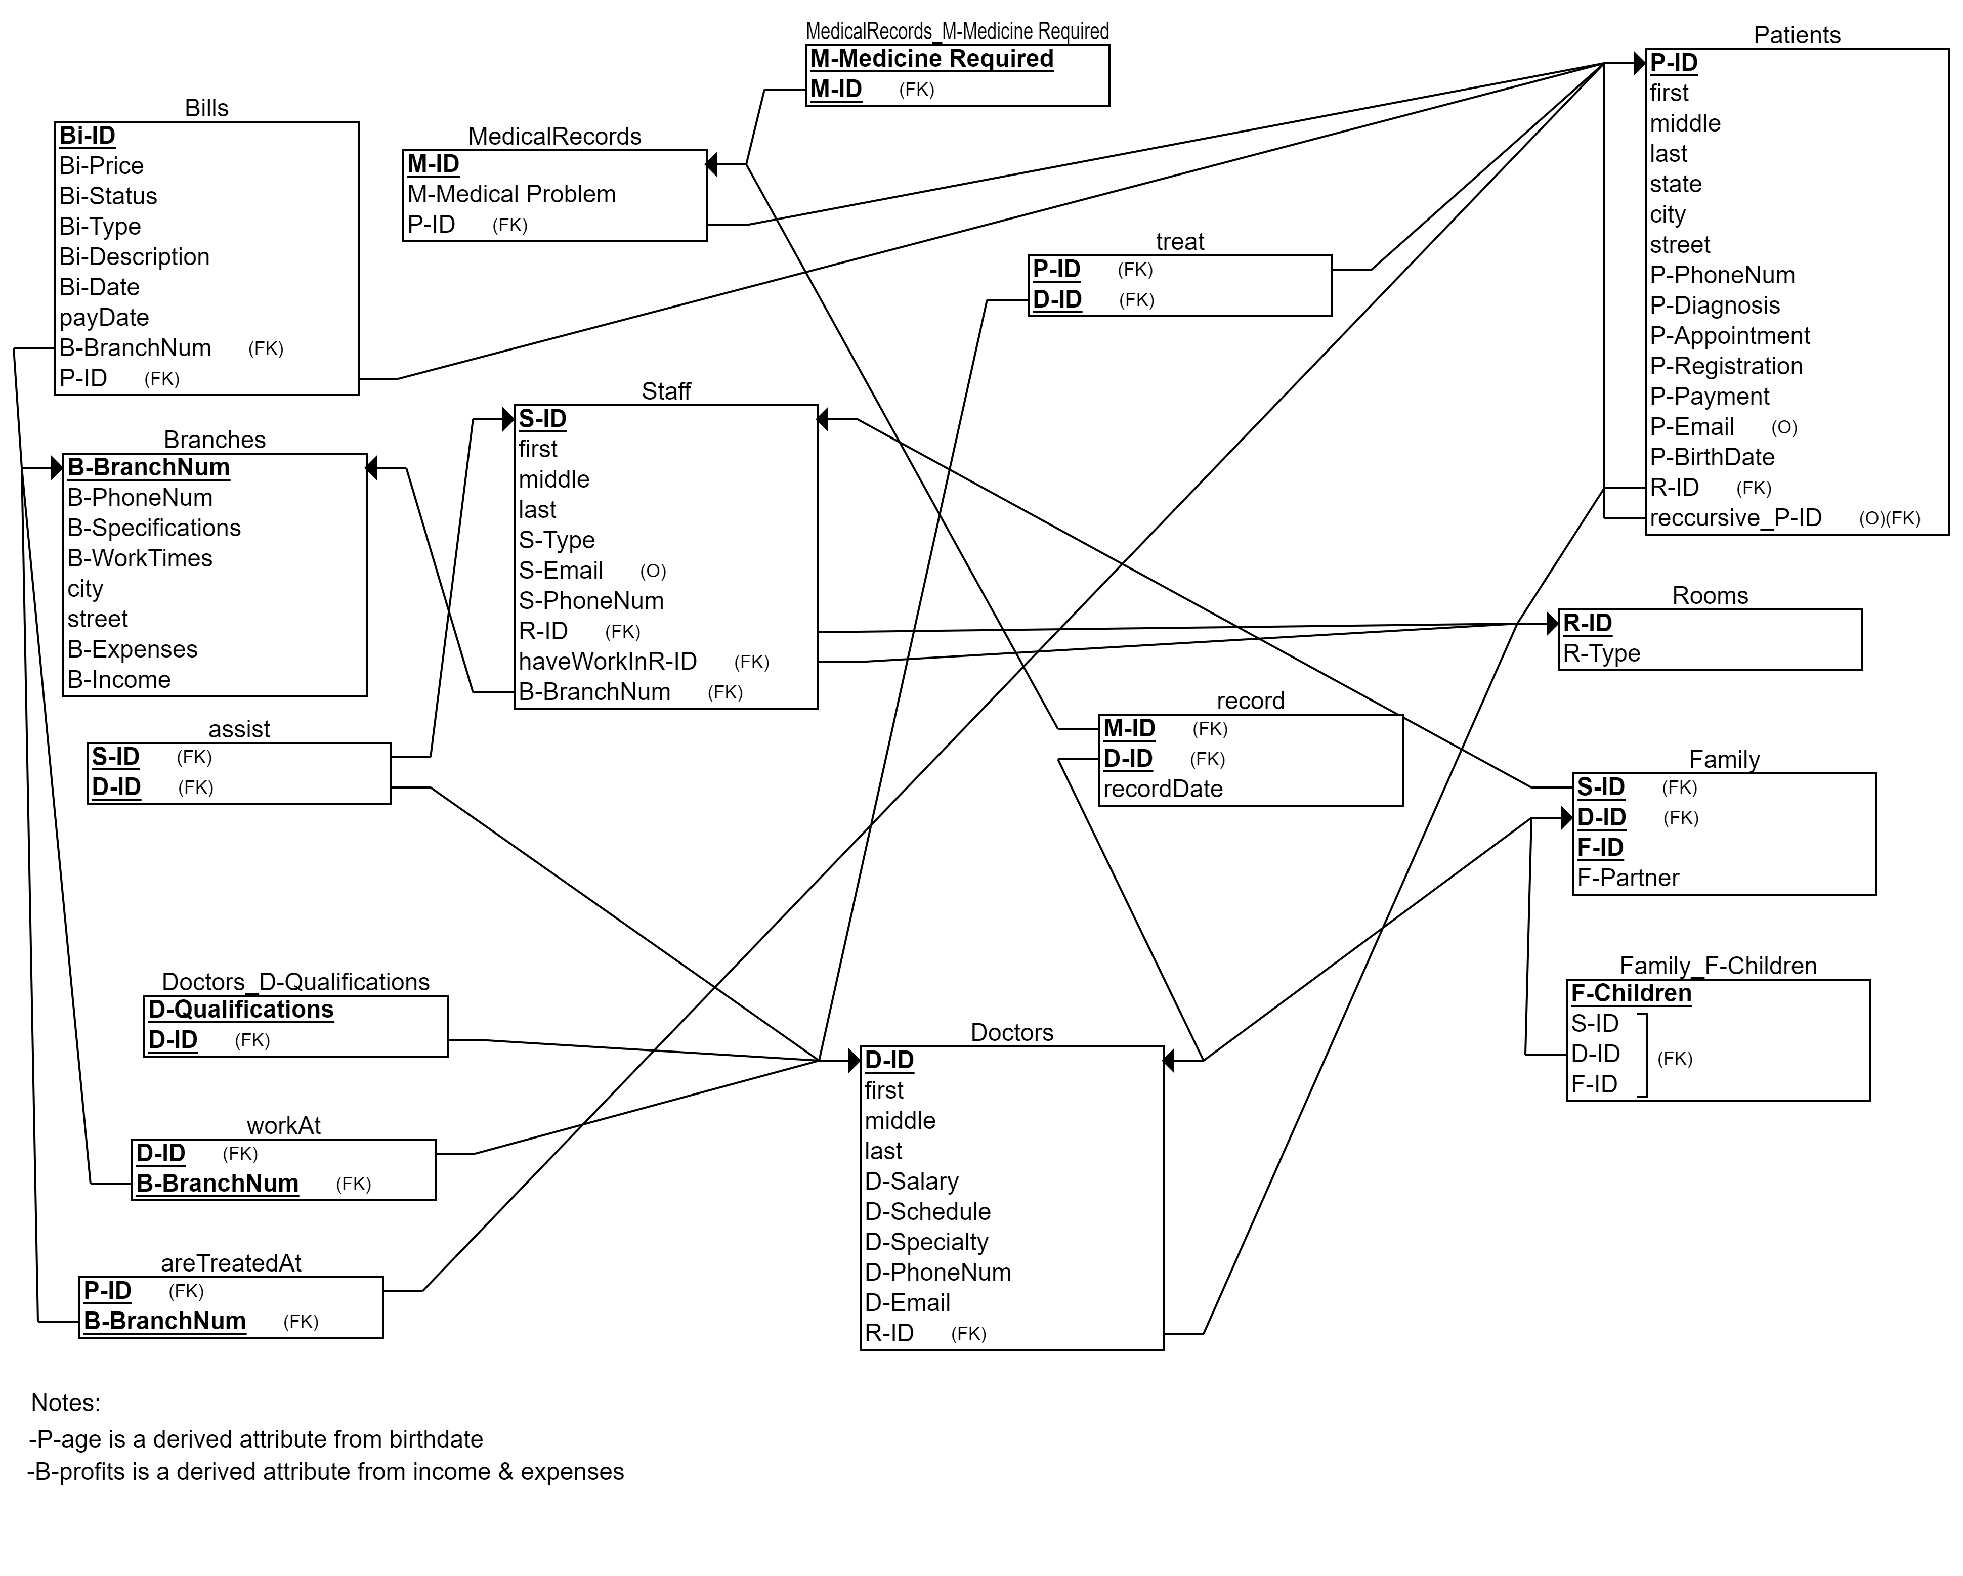

Figure Mapping